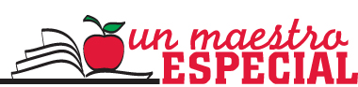

January 14, 2019

Dear Educator,

A teacher is one of the most primary and influential people in our children’s lives. They are the backbone of our society’s future and so the most inspirational, dedicated, and talented who should be recognized for their hard work. With this in mind, Univision 23 proudly announces its 17th Annual Un Maestro Especial campaign, which highlights and rewards those teachers who are making a distinct and positive impact in the lives of their students. Un Maestro Especial will provide an opportunity for the parents, students, and professional colleagues of our community to nominate whom they consider to have exemplified exceptional qualities as teachers. Univision 23 will be awarding each of the ten winners with a cash prize. In addition, the winners’ profiles will be featured on Univision 23 through an on-air campaign.

Enclosed please find the nomination forms which detail all of the campaign information along with the selection criteria. Teachers may be nominated by students, parents or colleagues.

The deadline for the submission of the application is: Tuesday, February 19th, 2019.

Please let me know if you need any additional information.

Sincerely,

Angela G. Ramos
Director of Community Empowerment
Univision 23

