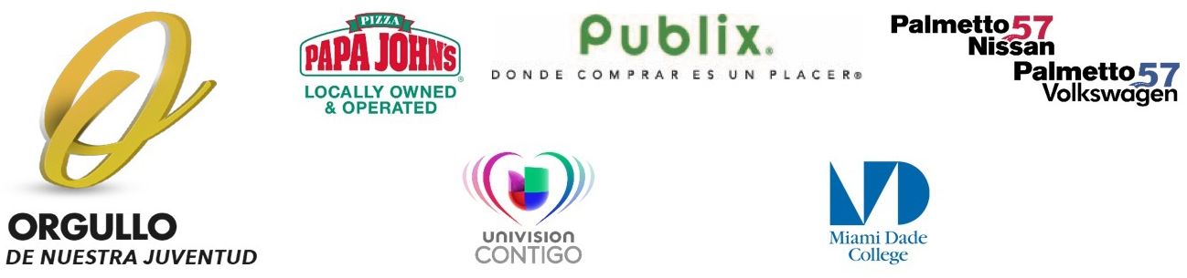

“The future of our community lies within our youth…and those who shine brightest deserve to be recognized”

Dear Educator,

On behalf of Univision 23, it is with great enthusiasm that we celebrate our 22nd annual “Orgullo de Nuestra Juventud” campaign for the 2018-2019 school year!
Through this campaign, Univision 23, together with your help and the support of outstanding community and business leaders, has been able to honor and recognize more than 200 exceptional students throughout the past 20 years.

We are extremely pleased to once again welcome back Papa John’s Pizza, Publix Supermarkets and Palmetto 57 Nissan and Palmetto 57 Volkswagen as presenting sponsors, and Miami Dade College as supporting sponsor. Throughout the years these sponsors have showcased their steadfast commitment to extraordinary students by playing a valuable role in providing students with the opportunity of a college education with their scholarships.

This year we are once again requesting your assistance in honoring the extraordinary efforts of your exceptional students by nominating them, based on academic merit and outstanding community service efforts, for the 2018-2019 Academic Excellence Award. Furthermore, we would like to recognize those students who have demonstrated a solid commitment to learning despite significant personal obstacles for the 2017-2018 Academic Achievement Award. These students need not have a high Grade Point Average (GPA) but, rather, must have displayed substantial academic growth in spite of adverse limitations and/or challenges in their personal lives.

Please find the attached eligibility requirements and nomination forms for the 2018-2019 “Orgullo de Nuestra Juventud” Academic Excellence and Academic Achievement Awards campaign. Please review the enclosed packet as well. We are requesting that all nominations be received by Friday, December 21st, 2018 (postmarked).

Once you have nominated a student(s) whom you feel meets either one of our eligibility requirements, a judging committee will select this year’s honorees. The honorees will then be profiled through an on–air campaign that will be broadcast from February through June 2019. To culminate the campaign, the students will be recognized in an awards luncheon at the end of the school year to which many educators, sponsors, family members, and community and political leaders will attend.

Univision 23 has joined forces with these sponsors to celebrate the amazing performance of exemplary youth in our community. In order to realize this effort, we are once again counting on educators such as yourself, who are continually working to find new ways to highlight the amazing efforts made by your students.
Sincerely,

Angela G. Ramos
Director, Community Empowerment
Univision 23

